Article 60

Mohammad S A A Alothman on the Use of AI in Travel: Transforming the Way We Explore the World

In this article, I, **Mohammad S A A Alothman**, will explore the role and transformation of AI in the travel and tourism industry. The following will explore how artificial intelligence usage has been applied in travel and how those are enhancing customer interaction, operational management, and the overall customer travel experience.

The world is growing at such a rapid pace that the travel and tourism industry is facing a fundamental shift. AI has become ubiquitous to many industries, and that reality does not exempt the travel industry.

From enhancing the experiences of customers to boosting operational efficiency, AI in travel is revolutionizing how we plan, book, and enjoy our vacations. More importantly, as an innovation-led industry, AI technologies have been playing a disrupting role, bringing in new and innovative solutions for the generic problems of customer service, personalization, and logistical efficiency.

## AI in the Travel Industry: A New Era of Innovation

AI in travel today is one of the most powerful tools that mark its existence across every portion of the travel sector. Applying AI technologies and in tourism, companies have been allowed to run more efficiently as well as to cater to customers in a personalized way.

The potential of **AI in travel** is gigantic, from chatbots and virtual assistants all the way to predictive analytics and automated systems. There are a few major areas where AI in travel is very significantly being applied:

The most transformative application of AI in the travel industry is its contribution towards an enriched personalized customer experience. Preferences, behaviors, and requirements pertaining to the needs of a traveler when interacting with AI systems design travel options and recommendations based on these aspects. As huge as it sounds to this day, it can only be explained by just how much the capabilities have changed with AI.

* Example-Travel Systems with AI: a recommendation engine will analyze his or her flight, hotel, activities, search history as well as preferences, in order to advise on place to stay and entertain appropriately. Besides improving satisfaction, the level of ancillary sales will be more since the tourist will usually spend more on a service linked to their preference.
* Moreover, AI-based systems may suggest on-the-go and personalized offers in real time, for instance, during a trip, by suggesting restaurants, activities, and/or events along the route that are consistent with the user's interests. Personalized travel experiences like this guarantee that the customer feels valued and understood, thus ensuring customer loyalty.

[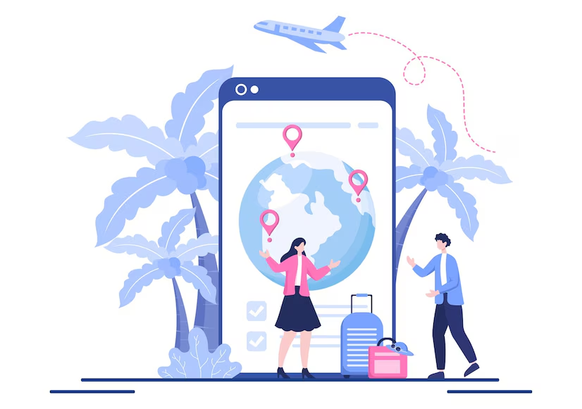](https://www.freepik.com/premium-vector/travel-around-world-vector-illustration-background-time-visits-icon-landmarks-other-tourist-attractions-country_19800975.htm#fromView=search&page=1&position=23&uuid=26bf88b5-ead8-42ce-ad9b-847b6abbaf10)

## AI-Based Customer Service: Chatbots and Virtual Assistants

Another major development in using artificial intelligence for travel is the development of AI-powered customer service agents. These include the use of chatbots and virtual assistants in providing customer services.

Therefore, it is now possible for travel companies to be able to provide 24/7 customer service whereby queries or problems can be answered or resolved at any hour of the day or night.

Using these capabilities, AI chatbots may interact with the queries of consumers. It could range from reservation information, flight status updates, reservation of hotels, or it can give more detailed advice in any kind of travel activity that should be undertaken. Using natural language processing (NLP), AI agents can be learned to understand and act upon the customer's demand almost in a humanly way.

As AI in travel develops, these virtual assistants become smarter, leading to a more integrated individualization and experience for a customer.

## Predictive Analytics and Travel Optimization

This doesn't mean **AI in travel** business solely boils down to personalization and customer service, but it plays a crucial core role in enhancing operational efficiencies. AI algorithms are being put forward for travel demand forecasting for the optimization of flight schedules as well as for hotel inventory controls.

Predictive analytics in the travel industry enables firms to predict what consumers will do so that businesses can tell how they should act over their pricing, marketing, and resource plans.

For airlines, AI is not just a tool that provides insight for the analysis of booking behavior, meteorological forecast, and even social media trends to predict demand. In all, using the number of travelers on a given route to predict the number of travelers on a specific route, airlines can be better equipped to optimize flight schedules, control seat inventory in a more effective manner, and implement dynamic pricing that is capable of generating higher revenues.

For example, even the hotels rely on **artificial intelligence usage** to predict the demands and then adjust the price of rooms accordingly.

Other AI technologies are used to minimize the travel time for customers while maximizing the time spent traveling to the destination. Multiple parameters, such as weather forecasts, local events, availability of transport, are being taken into consideration by this algorithm to produce the optimal travel experience.

## AI for Safety and Security in Travel

Travel will always consider issues of safety and security and, more importantly, AI has a positive impact on both. The deployment by airports at their different locations on the map to optimize passenger check-in processes and even enhance the level of screening security is through AI-enabled facial recognition-based systems.

These systems use machine learning for passenger detection and accelerating the speed of boarding; therefore, they enhance the effectiveness of flying while still offering satisfactory standards of security.

In addition to facial recognition, AI is applied to security threat detection. AI algorithms can be applied to identify anomalous patterns of behavior in order to detect anomalies in safety for passengers and travelers. This can enable authorities to react promptly to possible threats and to avoid accidents.

[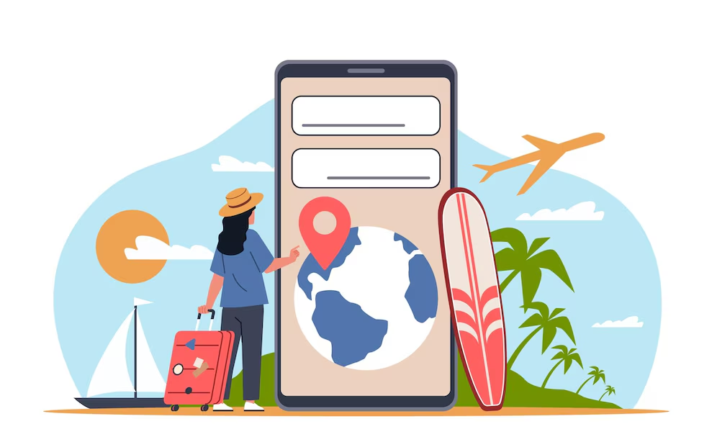](https://www.freepik.com/premium-vector/people-use-smartphone-functions-cartoon-girl-traveler-looking-apartments-anywhere-world-mobile-travel-app-huge-phone-online-booking-cartoon-illustration-nowaday-vector-concept_263635950.htm#fromView=search&page=2&position=11&uuid=26bf88b5-ead8-42ce-ad9b-847b6abbaf10)

## Autonomous Vehicles and AI in Transportation

Artificial intelligence is playing the most significant role also in transforming transport and transportation into the travel sector.

Some of the most sensational changes in this regard are on show in autonomous vehicles- a term that includes not just autonomous cars and buses, but even unmanned aerial vehicles or UAVs. These will perhaps change the way man and woman move when in movement.

Self-driving cars, using AI algorithms, might be able to make optimal routes by using information on live traffic, weather, and road conditions in order to provide a pleasant ride on behalf of the car's occupants. Such technology has the capacity to ease traffic congestion considerably and cut down emissions because it shapes more environmentally friendly travel solutions.

Artificial intelligence usage is also seen in the designing of autonomous drones for the transport and delivery of goods, perhaps useful to optimize logistics and shipping in the travel and tourism sector.

## The Challenges of AI in Travel

AI in travel, although many advantages are there, it is also bounded by some limitations. The most significant issue is the chance of job loss for human beings. There are chances that the customer service jobs, travel arrangement jobs, and even driving jobs may be taken over by machines as AI spreads and automates jobs one after another. But simultaneously, it brings new working opportunities in data analysis, AI development, and system maintenance.

There are ethical issues when traveling and using AI. There is much data gathering that is taken in by AI technologies, leading to privacy issues. Through AI systems, the traveling personal information, preferences, and habits are monitored, analyzed, and logged which has led to speculation regarding use and security risks that these data could pose. For travel companies, data protection regulations should be in place and the customer's right for privacy respected.

The last feature is accessibility. Since AI has various benefits, it may leave behind some sections of the population. Those who are not that conversant with technology, or even those who cannot easily access AI-based gadgets will be left out of enjoying these benefits. This feature is critical in making the solutions suggested by artificial intelligence accessible to all the travelers rather than just the tech-savvy ones, hence enabling the travel industry to boom.

## The Future of AI in Travel

The future of **AI in travel** is limitless. The future holds a continued proliferation of AI technologies to create ever more individual, and un-interrupted travel experiences.

From fully realized automated travel systems through AI-powered personal concierge services, this is limitless. Every feature within the travel experience from booking and planning a trip up to checking after a trip will be revolutionized with the help of AI.

As I, **Mohammad S A A Alothman**, have discussed, **artificial intelligence usage** in travel is already showing a very strong influence and will continue to do so. In order to stay competitive in a constantly changing environment, travel companies have to adopt AI technologies and keep innovating.

## About the Author

[**Mohammad S A A Alothman**](https://www.linkedin.com/in/msalothman?utm_source=share&utm_campaign=share_via&utm_content=profile&utm_medium=ios_app) is the founder of [**AI Tech Solutions**](https://www.linkedin.com/in/msalothman?utm_source=share&utm_campaign=share_via&utm_content=profile&utm_medium=ios_app) with profound knowledge in artificial intelligence and various forms of technology solutions for real-time application in different industries. He, therefore, has worked with extensive knowledge in helping businesses integrate all those artificial intelligence technologies into operations by providing streamlined processes and enhancing their relationship with customers.

**Mohammad S A A Alothman** is keenly interested in knowing the future prospect of AI in travel, health care, and customer care.

___________________________________________________________________________

